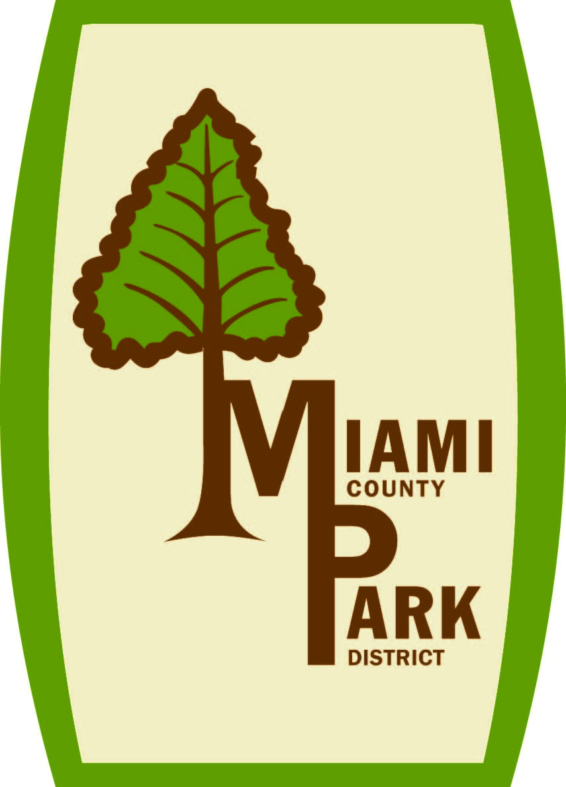
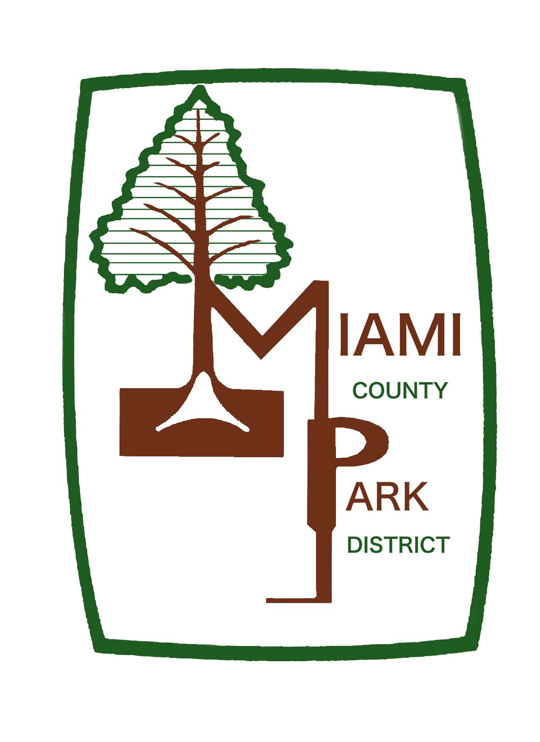
Travel/ Training Request & Reimbursement Form

Name __________________________ Title _______________________

Conference/ Training _____________________________________________

Where ________________________________ Date__________________

Registration fee $ _________

Travel __________miles @ $.30 = $ _________

Airfare __________ to _________ $ _________

Lodging __________ X _________= $ _________
Nights Rate

Meals Amount Requested = $ _________

Total amount charged to the Park District $ _________

Please reimburse me for any of these expenses that cannot be billed directly to the Park District. I will be financially responsible for all expenses above the approved amounts.

_______________________________________ _______________
Employee Signature Date of Request

_______________________________________ _______________
Director Date of Approval

Comments: ___________________________________________________________________
____________________________________________________________________________________________________________________________________________________________

